**Assignments on Generics**

1.Use a HashSet to hold Employee Objects. Upon running the application, the details of the employee added to the HashSet should be displayed.

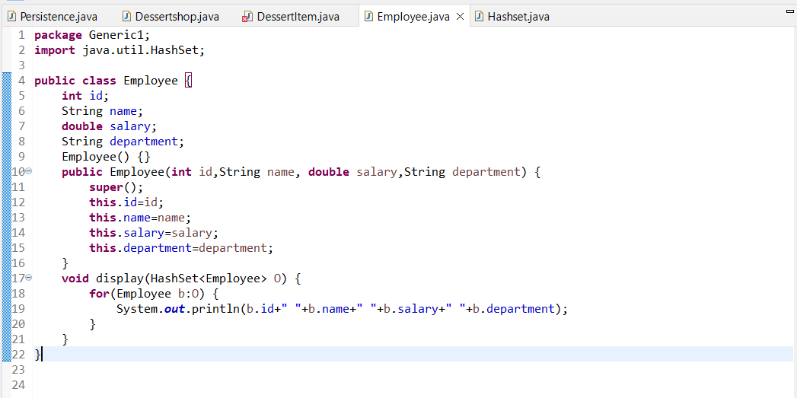

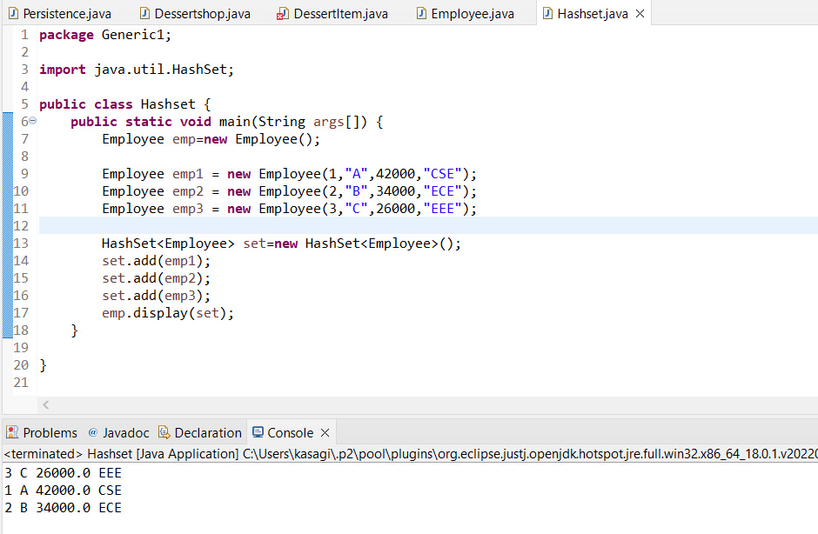

2.Write an application to hold 10 random int values as keys and 10 random double values as values for a HashMap. Print the data store in the HashMap.

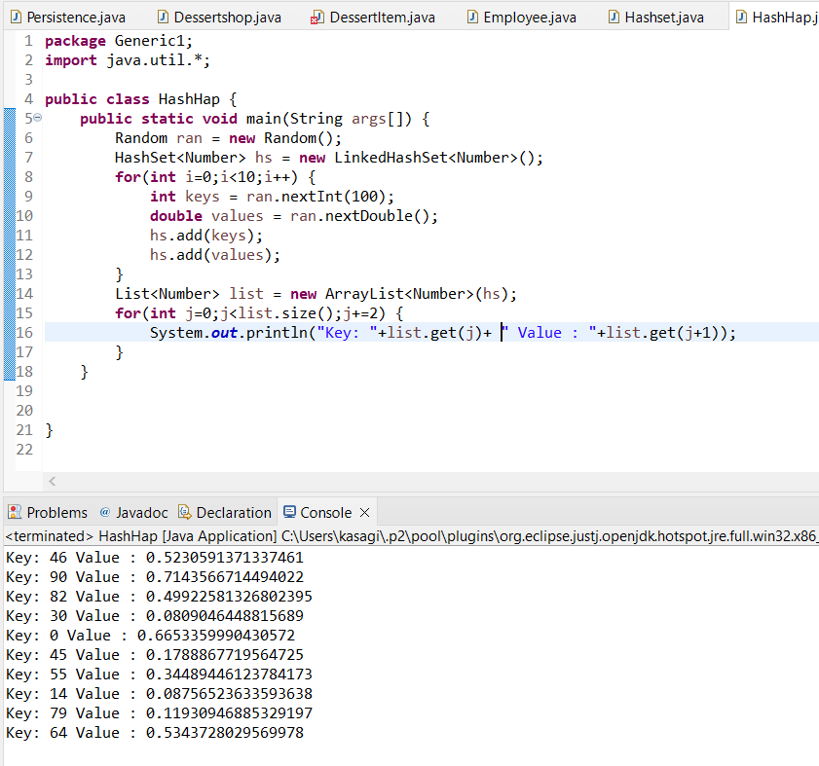

3.Write a generic method to exchange the positions of two different elements in an array.

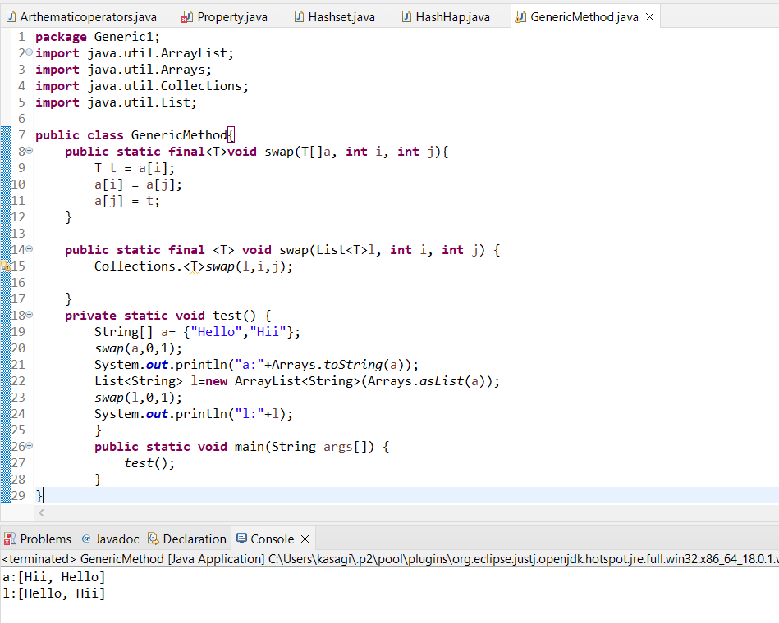

4.Design a class named Pair class to store String value for the property key and that of the second property is value.

